Motorbike Ladies Jacket art 1108  
1) add elastic waist 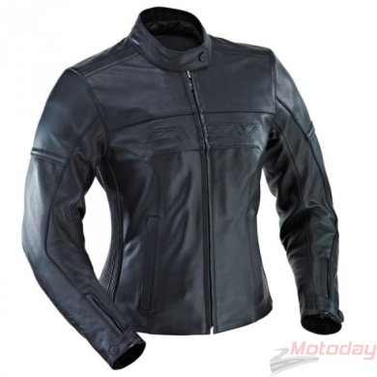

2)textile- stretch inserts in sleeves (photo), 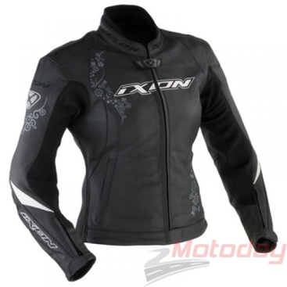

3) do something with sleeves from the elbow to the wrist because when its dressed protection of the elbow is mooving (not fix to the elbow, if somebody will fall there is big possibility that protection of the elbow will moove from elbow and damages will be)

4) put full zipper on the back one part sewed one not (both parts jacket and pants on the belt from the back)

5) collar ban - quality of the lines 