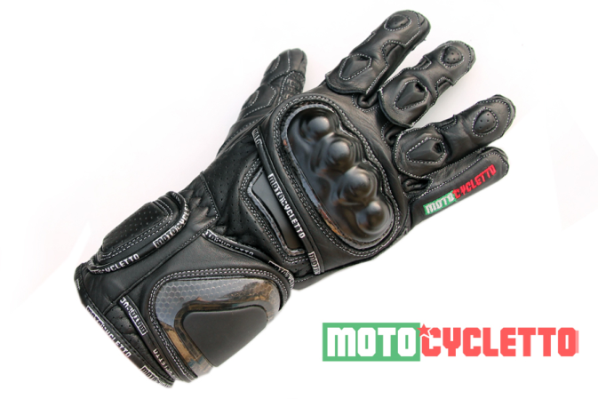

Gloves Super Sport Class

100% cowhide leather grade A +

Certified Carbon protectors

-The Joint TPU fingers

-On Knuckles fist CARBON

-On The inside of your wrist damping cushion

-On The ulnar side of the wrist TPU

-On The outer surface of the TPU hand

-The Palm (2 pieces) (protection of the scaphoid and the pisiform bone), the SPS

Under the protective layer of foam inserts for damping shock

The little finger and ring finger are paired single overlay

Fine textile lining

Double-layer of leather and double stitches in areas subject to critical loads

Anti-slip inserts on areas in contact with the control levers

Gloves are fixed at the wrist by three Velcro straps

On the index finger and thumb right gloves enclosing pad allows use of touchscreen devices, Iphone, Ipad, etc.



do the same but with outside seams on fingers (stiches - photo)